Renal Physiology (17 Questions on midterm)
- What is NOT a function of the kidney?
- Hormone production
- Excretion of Waste
- Glycolysis
- Maintain ion balance

- What is the correct order through the nephron?
- proximal tubule descending loop ascending loop distal convoluted tubule
- proximal loop descending tubule ascending tubule distal convoluted loop
- distal convoluted tubule descending loop ascending loop proximal tubule
- proximal tubule ascending loop descending loop distal convoluted tubule

- Which of the following is a transporter that increases activity in the presence of aldosterone?
- sodium/potassium ATPase in the proximal tubule
- sodium/potassium ATPase in the collecting duct
- sodium/hydrogen exchanger in the proximal tubule
- sodium/hydrogen exchanger in the collecting duct
- What is the difference(s) between cortical and juxtamedullary nephron?
- Both located in the cortex
- Cortical nephrons have a longer loop of Henle
- Juxtamedullary nephron is located in the medulla
- Humans have more juxtamedullary nephrons than cortical

- 1 and 3 are correct
- 2 and 4 are correct
- Only 1 is correct
- Only 4 is correct
- None of the above

- Which of the following causes the secretion of ADH?
- an increase in plasma osmolarity
- an increase in the activity of baroreceptors
- an increase in renin secretion
- an increase in sodium content of the filtrate

- At the afferent arteriolar end of a glomerular capillary, the glomerular capillary hydrostatic pressure is 50 mmHg. In Bowman’s space the hydrostatic pressure is 10 mmHg and the glomerular capillary oncotic osmotic pressure is 27 mmHg. Given these measurements, what is the value and direction of the net filtration pressure?

P_{GC} = 50 mmHg (Hydrostatic pressure of glomerular capillaries)
π_{GC} = 27 mmHg (Colloid osmotic pressure of glomerular capillaries)
P_{BC} = 10 mmHg (Hydrostatic pressure of Bowman’s capsule)
π_{BC} = 0 mmHg (Colloid osmotic pressure of Bowman’s capsule)

Formula for NFP = (P_{GC} + π_{BC}) – (P_{BC} + π_{GC})

Therefore, what is the answer to the question?
NFP = (50 + 0) – (10 + 27) = 13 mmHg

Direction of the filtration pressure?
The filtration pressure is in the direction of allowing more fluid to filter into the nephron.

- The glomerular hydrostatic pressure of the capillaries is 55 mmHg. In Bowman’s space the hydrostatic pressure is 15 mmHg and the colloid pressure is 5mmHg. Finally, the glomerular capillary oncotic pressure is 30 mmHg. Given these measurements, what is the value and direction of the net filtration pressure? Further, what is unique about this situation?

P_{GC} = 50 mmHg
π_{GC} = 30 mmHg
P_{BC} = 15 mmHg
π_{BC} = 5 mmHg

NFP = (50 + 5) – (15 + 30) = 10 mmHg

Direction = This is normal filtration pressure, thus normal filtration will still occur. even with protein in Bowman’s capsule.

What is unique about the pressures?

There is protein found within Bowman’s capsule, which leads to a colloid osmotic pressure of Bowman’s capsule.

- Fill in the blanks for the myogenic response…
High Glomerular filtration rate….

Afferent Arteriole: Stretches

Stretch sensitive ion channels: Open

Smooth muscle cells: Depolarize

Smooth muscle voltage-gated: Calcium channels open

Blood flow: Decreases
Glomerular filtration Decreases

- The glomerular filtration rate (GFR) is the amount of fluid filtered by the kidneys per day. This value can be used to determine if there are any problems with your kidneys. In order to measure this rate, you need to select a substance that is excreted 100% from your body. We cannot choose water to calculate this value because water is reabsorbed ~ 99%. However, a molecule called creatinine is excreted 100% by the body and this is typically used to determine your GFR. Keep in mind 2L of urine is produced/day.

- Calculate the glomerular filtration rate of 90mg/L of creatinine, assuming 1mg/L is found in the blood.
GFR (L/day) = ([Creatinine] urine * urine/day])/[Creatinine]plasma
= (90mg/L * 2L)/(1 mg/L)
= 180 L/day
- Calculate the glomerular filtration rate when 0.07mg/ml of creatinine is found in the urine, assuming 1x10⁻³mg/ml is found in the blood.
GFR (L/day) = ([Creatinine] urine * urine/day])/[Creatinine]plasma
= (.07mg/ml * 2000ml)/ (.001 mg/ml)
= 140,000 ml/day
= 140 L/day
- Calculate the glomerular filtration rate when 0.075g/L of creatinine is found in the urine, assuming 0.001 g/L is found in the blood.
* Note: You do not need to perform any conversions since grams will cancel out.

GFR (L/day) = ([Creatinine] urine * urine/day])/[Creatinine]plasma
= (.075g/L * 2L)/ (.001 g/L)
= 150 L/day

- Let’s apply this concept to handling of various products in the renal system. Remember that normal GFR is 180L/day or 125mg/min.
- You have 4.5 g/L of sodium in your blood plasma and you have excreted 3.9 g through urine. What is the filtered load of sodium, what percentage was excreted and what percentage was reabsorbed?

Filtered load of sodium = [substance]plasma x GFR
= 4.5 g/L * 180 L
= 810 g/day

% Excreted = (Amount excreted/Filtered load) * 100
= (3.9/810) * 100
= 0.48 %
% Reabsorbed = 100 - % excreted
= 100 – 0.48
= 99.52 %
- You have 4.5 g/L of sodium in your blood plasma and you have excreted 3.9 g through urine. What is the filtered load of sodium, what percentage was excreted and what percentage was reabsorbed? Assume GFR is the value you calculated from question 7 part b.
Filtered load of sodium = [substance]plasma x GFR
= 4.5 g/L * 150 L
= 675 g/day

% Excreted = (Amount excreted/Filtered load) * 100
= (3.9/675) * 100
= 0.58 %
% Reabsorbed = 100 - % excreted
= 100 – 0.58
= 99.42 %
You can see if your GFR is lower your body will reabsorbed less and more of the substance will be excreted.

- You have 0.8 g/L of urea in your blood plasma and you have excreted 20 g through urine. What is the filtered load of sodium, what percentage was excreted and what percentage was reabsorbed? Assume GFR is 135mg/min and express answer as g/day.

GFR = 135 mg/min * .001 g = 0.135 g/min * 60 * 24 = 194.4 g/day

Filtered load of urea = [substance]plasma x GFR
= 0.8 *194.4
= 155.52 g/day

% Excreted = (Amount excreted/Filtered load) * 100
= (20 /155.52) * 100
= 12.86 %
% Reabsorbed = 100 - % excreted
= 100 – 12.86
= 87.14 %

- You have 0.9 g/L of glucose in your blood plasma and you have excreted 0.5 g through urine. What is the filtered load of glucose, what percentage was excreted and what percentage was reabsorbed? What could you say may be the cause of the extra glucose excretion? Assume GFR is 180 L/day.
Filtered load of glucose = [substance]plasma x GFR
= 0.9 *180
= 162 g/day

% Excreted = (Amount excreted/Filtered load) * 100
= (0.5 /162) * 100
= 0.31 %
% Reabsorbed = 100 - % excreted
= 100 – 0.31
= 99.69 %
The excreted glucose in the urine may be the result of diabetes mellitus.

Respiratory Physiology (14 Questions on midterm)
- Which one of the following is true about a pneumothorax?
- transpulmonary pressure becomes +5 mmHg during a pneumothorax
- a pneumothorax causes both lungs to collapse
- damage to the visceral pleura would allow air to escape from inside the lung into the intrapleural space
- the intrapleural space fills with fluid during a pneumothorax

- If in one breath a person takes in a larger tidal volume than they normally would, which one of the following statements would be correct?
- they are likely be breathing in less than 500 mL (0.5 litres)
- they would have a smaller IRV (inspiratory reserve volume)
- they would have a larger total lung capacity
- they would have a smaller FEV1

- What is the pulmonary ventilation and alveolar ventilation for a 150lbs person, with a respiratory rate of 20 breaths/min and tidal volume of 200mL/breath?

Pulmonary ventilation = Tidal Volume * Respiratory Rate
= 20 breaths/min * 200ml/breath
= 4000 ml/min
Alveolar ventilation = Pulmonary ventilation – Ventilation Dead Space
= (4000) – (150lbs * 20 breaths/min)
= 1000 ml/min

- Complete this table on muscle contraction during inspiration and expiration at rest and exercise.
 | Inspiration |  | Expiration
 | At rest | During exercise | At rest | During exercise
Diaphragm (contract/relax) | Contract | Contract | Relax | Relax
Internal intercostals | ---- | ---- | ---- | Contract
External intercostals | Contract | Contract | ---- | ----
Obliques | ---- | ---- | ---- | Contract
Abs | ---- | ---- | ---- | Contract

- Label the following on this figure: Tidal volume, inspiratory reserve volume, expiratory reserve volume, residual volume, vital capacity and total lung capacity.
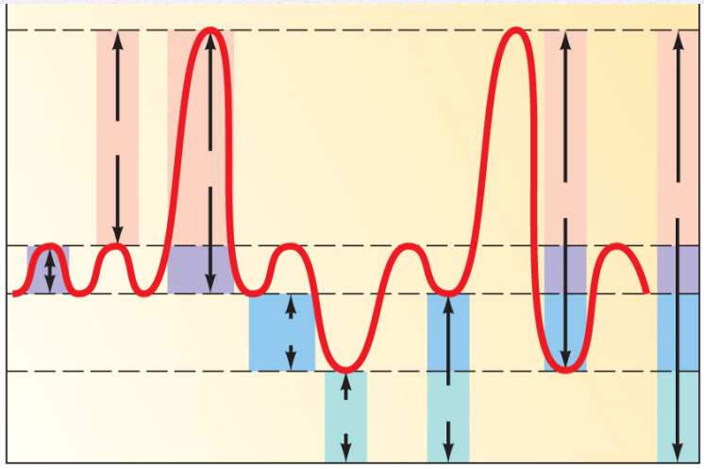

Inspiratory reserve volume
Vital capacity

Total lung capacity

Expiratory reserve volume
Tidal volume

Residual volume

- Give an example of an obstructive lung disease? How does the FEV1 and FVC change?
Obstructive lung diseases consist of asthma, bronchitis and emphysema. There is a decrease in FEV1 but a normal FVC. This means the amount you are able to exhale in 1 second is much less but the total volume remains unaffected.

- Give an example of a restrictive lung disease? How does the FEV1 and FVC change?
Pulmonary fibrosis is an example of a restrictive lung disease. There is a decrease in FVC but a normal FEV1. This means the amount you are able to exhale in 1 second is normal but your lungs have a lower volume of total air.

- Fill in the following diagram showing the partial pressures of O2 and CO2.
Atmospheric PO₂ = 160 mmHg
Atmospheric PCO₂ = 0.3 mmHg

3 General Rules
1. Gases move from high pressure to low
2. Gases move until equilibrium
3. Gases only move at capillaries

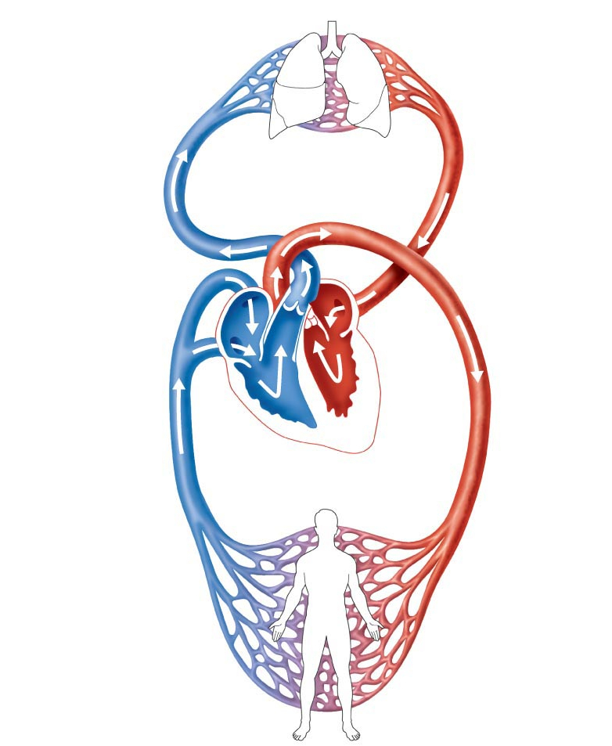
Alveolar PO₂ = 100 mmHg
Alveolar PCO₂ = 40 mmHg

Pulmonary Artery PO₂ = 40 mmHg
Pulmonary Artery PCO₂ = 46 mmHg

Pulmonary circulation
capillaries

Pulmonary Vein PO₂ = 100 mmHg
Pulmonary Vein PCO₂ = 40 mmHg

Systemic Artery PO₂ = 100 mmHg
Systemic Artery PCO₂ = 40 mmHg

Systemic Vein PO₂ = 40 mmHg
Systemic Vein PCO₂ = 46 mmHg

Systemic circulation
capillaries

Body Tissue PO₂ = 40 mmHg
Body Tissue PCO₂ = 46 mmHg

