Renal Physiology – Label the Diagrams
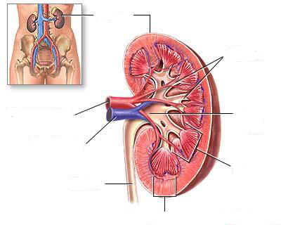

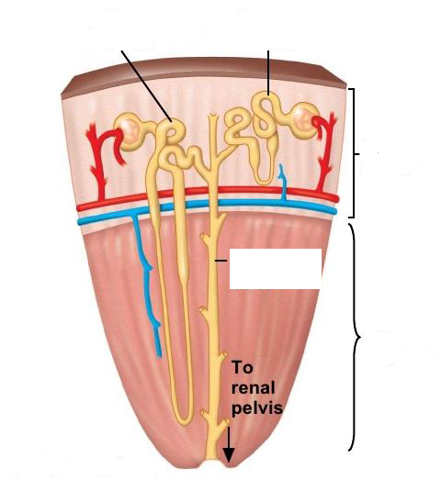

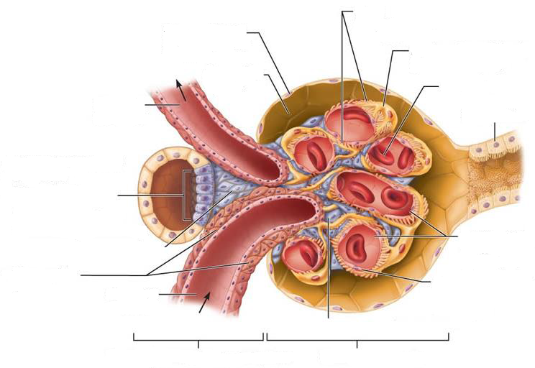

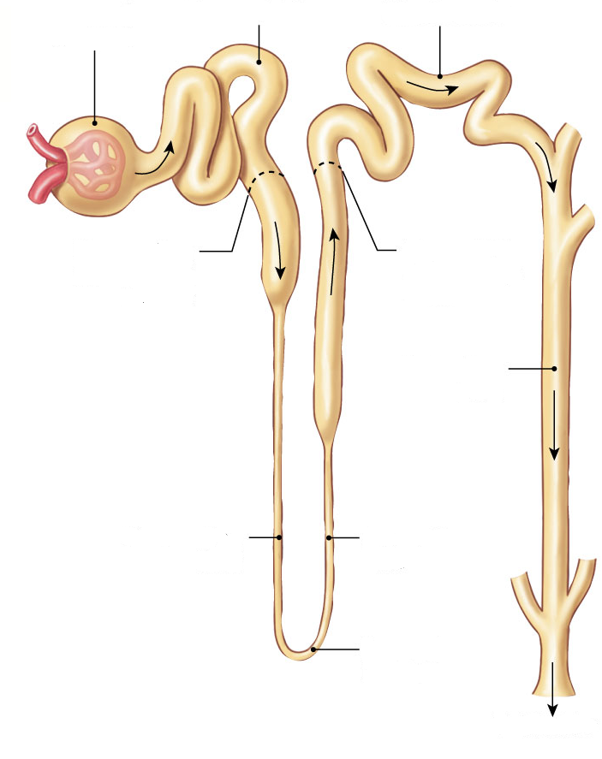

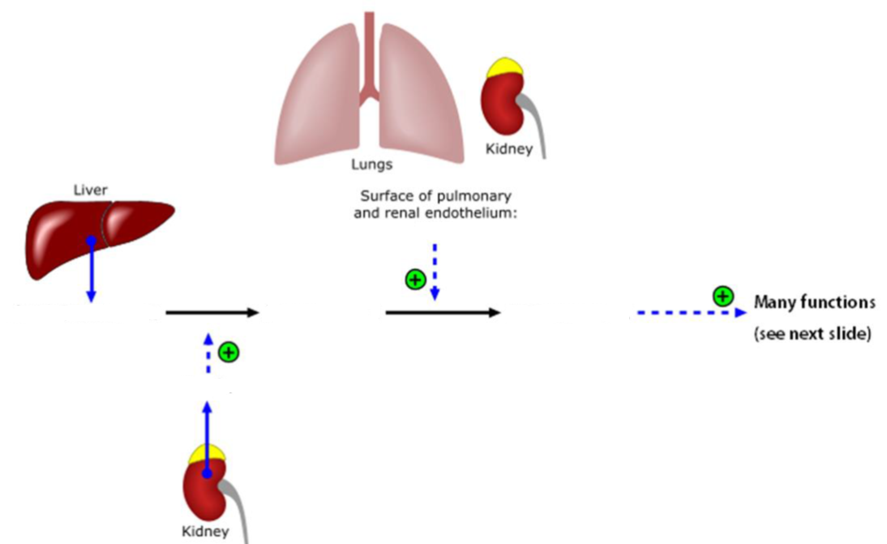

# of amino acids: ______
# of amino acids: ______
# of amino acids: ______
Released in response to: _____________

RATE LIMITING ENZYME?: _____________

Renal Physiology – Fill In The Tables
Three key process that occur in kidneys
 | Filtration | Reabsorption | Secretion
Where does it occur?
From _____ to _____.
Overall

Glomerular Filtration
 | Hydrostatic Pressure of Glomerular Capillaries | Colloid Osmotic Pressure of Glomerular Capillaries | Hydrostatic Pressure of Bowman’s Capsule | Colloid Osmotic Pressure of Bowman’s Capsule
Abbreviation
Caused by
Filtration
mmHg

Net filtration pressures
 | P_{GC} | π_{GC} | P_{BC} | π_{BC}
Filtration
mmHg

GFR Regulation
 | Afferent Arteriole |  | Efferent Arteriole
Smooth Muscle
GFR

Reabsorption along the tubule
Segment of Tubule | Substances | Hormone Regulation | Percent
Proximal Tubule
Descending Limb of LOH
Ascending Limb of LOH
Distal Tubule
Collecting Duct

Summary of transport in kidneys
 | Proximal Tubule | Descending Limb | Ascending Limb | Distal Tubule | Collecting Duct
Goal
Water
Ions
Paracellular Transport
Hormone Regulation

Respiratory Physiology – Label the Diagrams
zone
zone
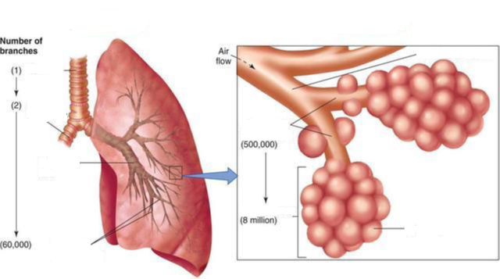

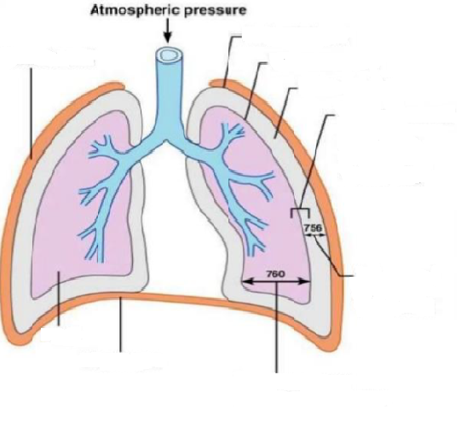

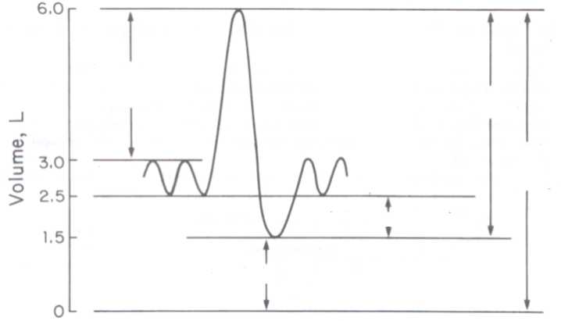

Name of device used to produce these graphs?: _________________

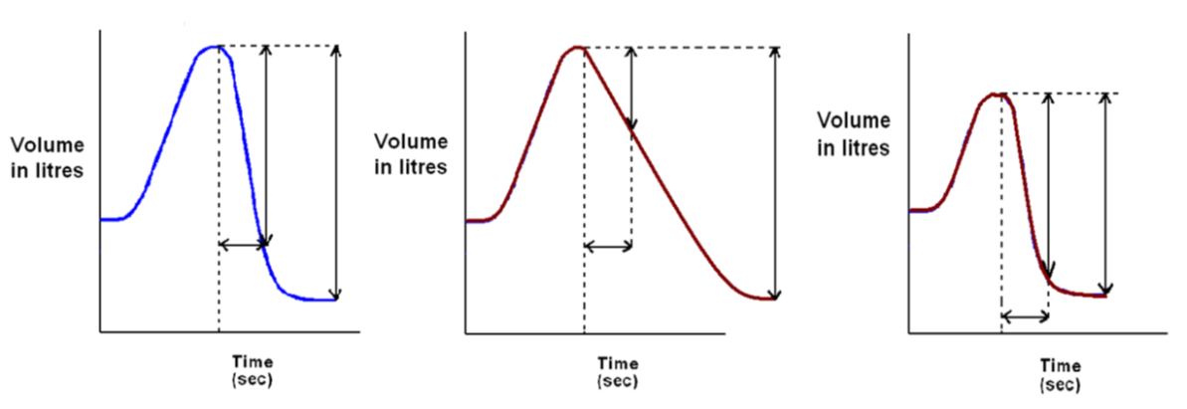

FEV₁/FVC ratio = _______
FEV₁/FVC ratio = _______
FEV₁/FVC ratio = _______

Respiratory Physiology – Fill In The Tables

FEV1/FVC in Diseases
 | Obstructive | Restrictive
FEV1
FVC
FEV1/FVC = 80 % (Normal)
Examples

Obstructive Lung Diseases
Example | Cause | Effect

Restrictive Lung Diseases
Example | Cause | Effect
Pulmonary Fibrosis

Chemoreceptors
 | Central | Peripheral
Location
Respond to changes in

