Renal Physiology – Label the Diagrams
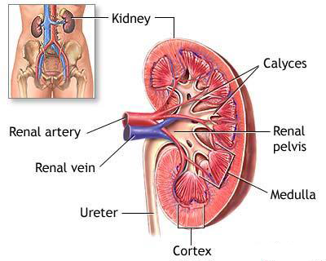

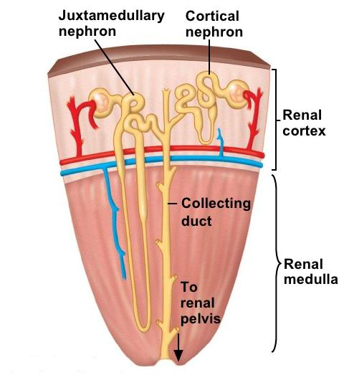

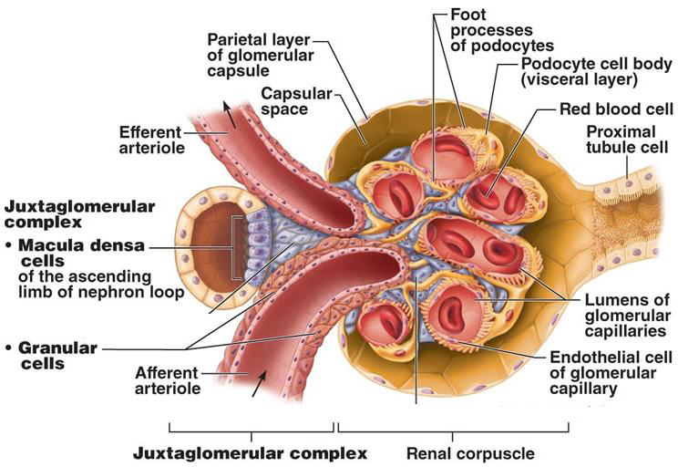

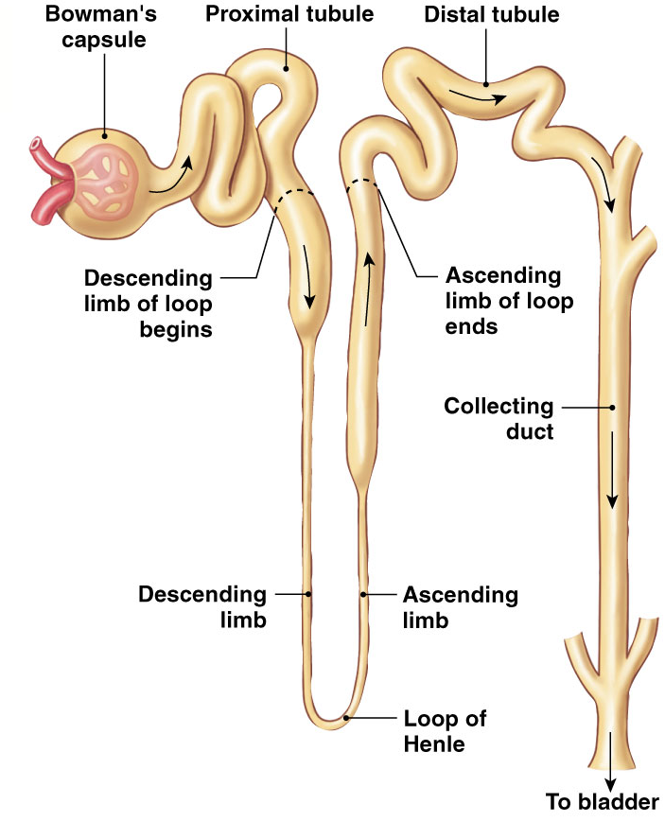

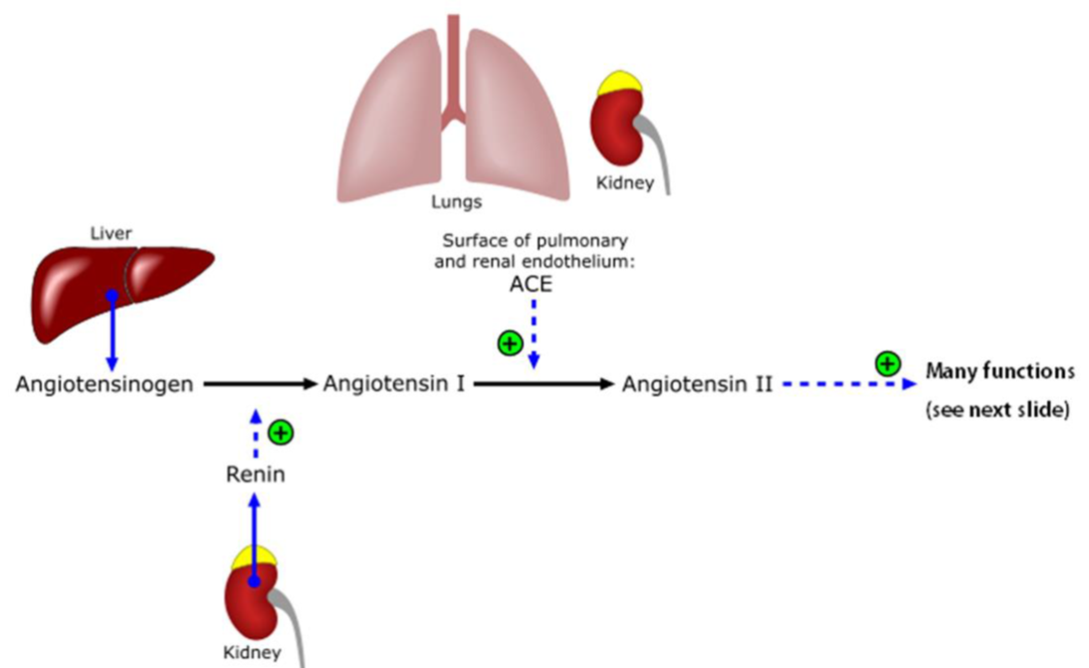

Angiotensin Converting Enzyme

# of amino acids: 8
# of amino acids: 10
# of amino acids: 452

Released in response to: decrease in Na levels

RATE LIMITING ENZYME?: Renin

Renal Physiology – Fill In The Tables
Three key process that occur in kidneys
 | Filtration | Reabsorption | Secretion
Where does it occur? | Renal Corpuscle | Tubule | Tubule
From _____ to _____. | From glomerular capillaries to Bowman’s space | From lumen of tubule to surrounding capillaries (peritubular/ vasa recta) | From surrounding capillaries (peritubular/ vasa recta) to lumen of tubule to
Overall | Blood Pre-urine (filtrate) | Removes from filtrate (e.g. body wants to keep) | Adds to filtrate (e.g. body wants to remove as waste)

Glomerular Filtration
 | Hydrostatic Pressure of Glomerular Capillaries | Colloid Osmotic Pressure of Glomerular Capillaries | Hydrostatic Pressure of Bowman’s Capsule | Colloid Osmotic Pressure of Bowman’s Capsule
Abbreviation | P_{GC} | π_{GC} | P_{BC} | π_{BC}
Caused by | Blood flowing into glomerulus | Presence of proteins in glomerulus | Filtrate remaining in Bowman’s space | Presence of proteins in Bowman’s space
Filtration | Promotes | Inhibits | Inhibits | Promotes
mmHg | 55 | 30 | 15 | 0

Net filtration pressures
 | P_{GC} | π_{GC} | P_{BC} | π_{BC}
Filtration | Promotes | Inhibits | Inhibits | Promotes
mmHg | 55 | 30 | 15 | 0

GFR Regulation
 | Afferent Arteriole |  | Efferent Arteriole
Smooth Muscle | Dilate | Constrict | Dilate | Constrict
GFR | Increases | Decreases | Decreases | Increases

Reabsorption along the tubule
Segment of Tubule | Substances | Hormone Regulation | Percent
Proximal Tubule | Glucose, amino acids, H₂O, Na⁺, K⁺, Cl⁻ | Yes | 65%
Descending Limb of LOH | H₂O, minimal Na⁺ | No | 20 %
Ascending Limb of LOH | Na⁺, K⁺, Cl⁻ | No
Distal Tubule | Na⁺, K⁺, Cl⁻ , Ca²⁺ | Yes | 14%
Collecting Duct | H₂O, Na⁺ | Yes

Summary of transport in kidneys
 | Proximal Tubule | Descending Limb | Ascending Limb | Distal Tubule | Collecting Duct
Goal | Reabsorption of everything | Water reabsorption | Ion reabsorption | Ion reabsorption | Fine tuning (water and Na)
Water | Yes | Yes | No | No | Yes
Ions | Yes (Na⁺, Cl⁻, K⁺) | Yes (Na⁺) | Yes (Na⁺, Cl⁻, K⁺) | Yes (Na⁺, Cl⁻, K⁺, Ca²⁺) | Yes (Na⁺)
Paracellular Transport | Yes | No | Yes | No | No
Hormone Regulation | Angiotensin II | - | - | PTH | Aldosterone  ADH
Respiratory Physiology – Label the Diagrams
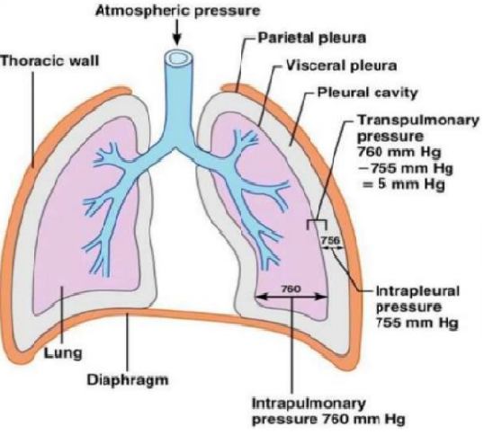
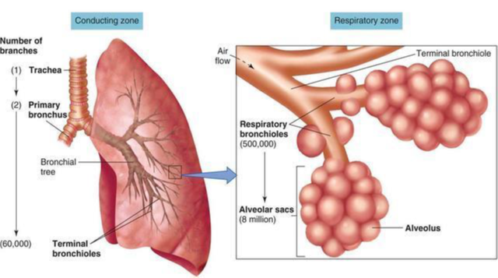

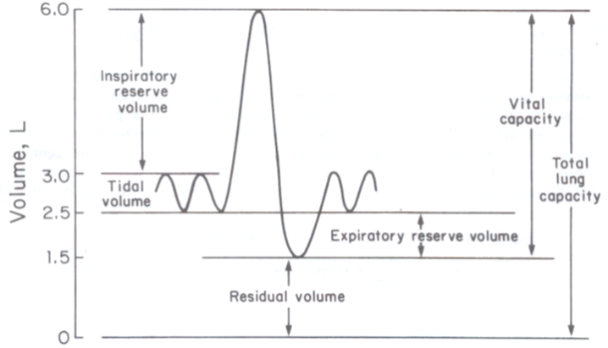

Name of device used to produce these graphs?: Spirometer

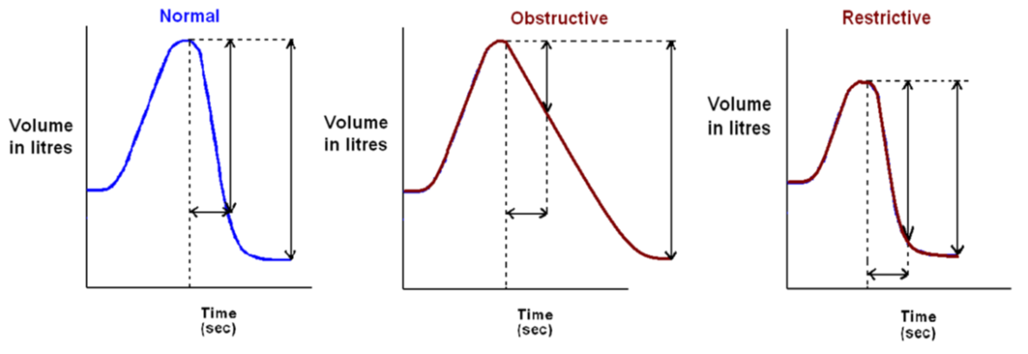

FVC
FEV₁
FEV₁/FVC ratio = more than 80%
FEV₁/FVC ratio = less than 80%
FEV₁/FVC ratio = 80%

Respiratory Physiology – Fill In The Tables

FEV1/FVC in Diseases
 | Obstructive | Restrictive
FEV1 | Decreases | No Change
FVC | No Change | Decreases
FEV1/FVC = 80 % (Normal) | FEV1/FVC < 80% | FEV1/FVC > 80%
Examples | Asthma, chronic bronchitis, emphysema | Pulmonary fibrosis

Obstructive Lung Diseases
Example | Cause | Effect
Asthma | Spasms triggered by exercise, air pollution and allergies | Airway inflammation and hyper-responsiveness
Chronic Bronchitis | Smoking | Excessive mucus and inflammation
Emphysema | Smoking | Alveolar wall breaks down creates large air sacs (decrease surface area = poor gas exchange). Loss of elastin reduces elastic recoil (increase compliance so lungs fill but can’t empty)

Restrictive Lung Diseases
Example | Cause | Effect
Pulmonary Fibrosis | Chronic inhalation of asbestos, coal, dust, pollution or sometimes unknown | - Fibrous scar tissue (thickened tissue) in alveoli and other lung tissue  - Due to thick walls, poor gas exchange (similar to emphysema but different reason)  - Lungs become stiff due to increase in collagen = decrease compliance (opposite to emphysema)

Chemoreceptors
 | Central | Peripheral
Location | Medulla | Aortic arch and carotid body
Respond to changes in | pH only  Note: H⁺ cannot cross the blood brain barrier, but CO₂ can. So CO₂ is converted into bicarbonate and H⁺ in CSF for detection | PO₂  PCO₂  pH

